Table of Contents
Chapter 24 - Multilayer Perceptrons 2
XOR, Backpropagation, and non-lineariaties 2
24.1 - Introduction 2
24.2 - Minsky and Papert's monkey wrench 3
24.3 - Enter Backpropagation 5
24.4 - Backpropagation in a nutshell 6
24.4 - Scikit-learn 9
24.5 - The XOR Problem revisited 10
24.6 - 2-layer neural network and linear regression 10
24.7 - Testing for linear seperability 14
24.8 - 2-layer Perceptrons with a linear activation function 17
24.9 - Non-linear activation functions 17
24.10 - Linear, Tanh and Sigmoid activation functions 19
24.11 - Multi-Layer neural networks with linear activation functions 21
24.12 - A Multi-layer perceptron with strictly linear acitivation functions. 21
24.13 - Multlayer neural network with non-linear activiation functions 22
24.14 - Predicting Breast Cancer Risk 23
24.15 - Predicting Genre from Spotify Audio Features 24
24.16 - Conclusion 24
24.17 - References 24

Chapter 24 - Multilayer Perceptrons

XOR, Backpropagation, and non-lineariaties

24.1 - Introduction
Wait? Another chapter on neural networks to work through before we discuss what you really like to read about? Don't worry, we will get to deep belief neural networks (DBNNs) soon enough (i.e. the next chapter). To be honest, the phrase 'deep belief neural network' to us is more of a rebranding than a logical progression from the multilayer neural networks that preceeded them. Google the definition of 'deep belief neural network' and you will likely find that what best defines a DBNN is that it has 1 or (many) more hidden layers. Hidden layers are layers that neither received direct inputs and neither are their outputs the final output. Instead, they receive intermediate levels of activation from previous layers, which can be both other hidden layers themselves, or the input layer. Similarly, hidden layers might send their activity to the final output layer, or instead pass it along to a next hidden layer. And if you look up the definition of a multilayer neural network, say a multilayer perceptron, you will find a very similar definition. Both terms refer to neural networks that have one or more intermediate (or hidden) layers in between the input and output layers. Multilayer neural networks were the first step towards such networks, and were made possible by the discovery (or invention, it is hard to find a proper verb for how new algorithms come into being) of backpropagation. In addition, new activation functions introduced non-linearities that in turn allowed for more complicated mapping of inputs onto outputs. To us, DBNNs are a continuation of this research, finding even better activation functions, creating more adaptive gradient descent
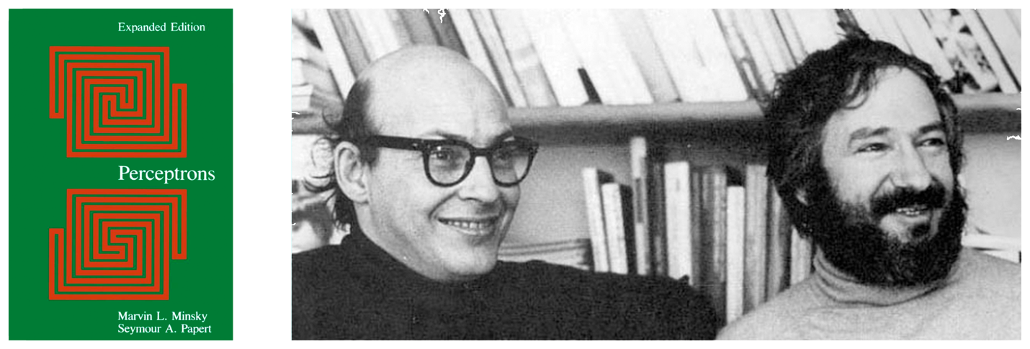
Figure 24.1 - In their 16969 book 'Perceptrons', Marvin Minsky (left) and Seymour Papert provided the evidence that more complicated and interesting computational problems required the introduction of both non-linearities and hidden layers, if neural networks would ever be used to solve them.

variants, finding new ways to increase neural network stability, optimize learning, and preventing the increasingly larger neural nets from overfitting the data with even bigger data sets.

24.2 - Minsky and Papert's monkey wrench
In the previous chapter, we build our first ANNs and turned them into simple logic gates. In adidtion, we used them to classify a relatively simple simulated but noisy dataset. And, in discussing the history of ANNs, we paused at Paul Rosenblatt's Perceptron and his learning rule to train it automatically. For good reason. A few years after the Preceptron was introduced, Marvin Minsky and Seymour Papert (1969) published the book 'Perceptron - an introduction to computational geometry', see Fig. 24.1. In it, the authors unequivocally demonstrated that certain computational problems could never be computed by the input-output neural networks of the day, with the XOR logic gate being a classic example, see
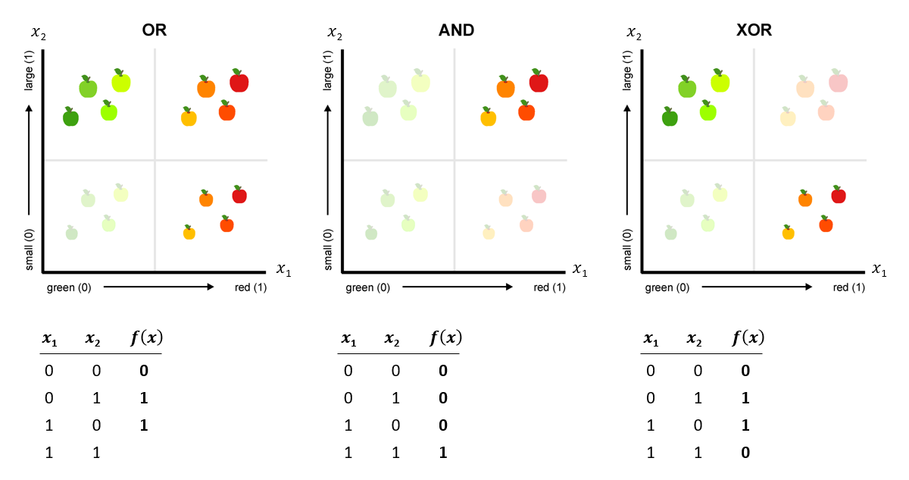
Figure 24.2 - The infamous XOR problem. Classifying apples as being large OR red, or classifying apples being both large AND red can be done with a single input-output neural network. In both bases, an infinite number of linear functions exist that divide the two classes according to their desired label (large and red, large or red). However, when we are trying to distinguish apples as large and green or small and red from those that are large and red or small and green, no such linear function exists to neatly divide the examples into their two classes.

Fig. 24.2. While this is certainly true, is was also understood that many types of problems could easily be solved by ANNs by introducing hidden (i.e. intermediate ) layers in between the input/output layers on Rosenblatt’s perceptron. However, there were no algorithms that could apply Rosenblatt’s learning rule to update the weights in such multilayer networks ( which at the time were typically referred to as multilayer perceptrons). This led to the decline in the interest of neural works, and the focus of AI shifted to logic and rule-based knowledge systems instead.

24.3 - Enter Backpropagation
Fortunately, a solution was found a few years later. And that solution is still at the heart of our ANNs. Although the timeline and order in which backpropgation was introduced to the neural network community is somewhat convoluted, many agree that Werbos, extending his original 1975 thesis, introduced the neural network specific implementation in 1982 (Werbos, 1975, 1982). But it would be unfair, in our opinion, to not also give credit to Linnainmaa, a Finish student describing a precursor of the algorithm in his 1970 thesis (Linnainmaa, 1970). A combination of backpropogation and gradient descent proved to be a powerful tool for training multilayer perceptions. It allowed us, theoretically, to train neural networks of any number of hidden layers. We use the word theorectically here because eventhough backpropgation did solve the problem of training multilayer neural networks, it is slow and computationally very taxing, especially on the hardware of that era. Nevertheless, ANNs were again an active topic of research, eventhough the neural networks being build were too small to solve actual practical real world problems for quite some time. Before we dive in to the idea, intuition and a little bit of math, it is worth noting a slight problem with backpropgation when it comes to biological neural networks. Simply put: there is no evidence brains use a similar algorithm or mechanisms to achieve learning. Whereas most other components of a modern ANN are abstractions that can be mapped on known biological neural networks, backpropogation cannot. That is fine if you are interested just building a functional and accurate ANN. However, recently, the big neural networks have started to show some disturbing errors that do seem to strongly suggest ANNs have diverged significantly brom the biological counterparts, as these errors are not seen in biological systems. We will come back to this later.
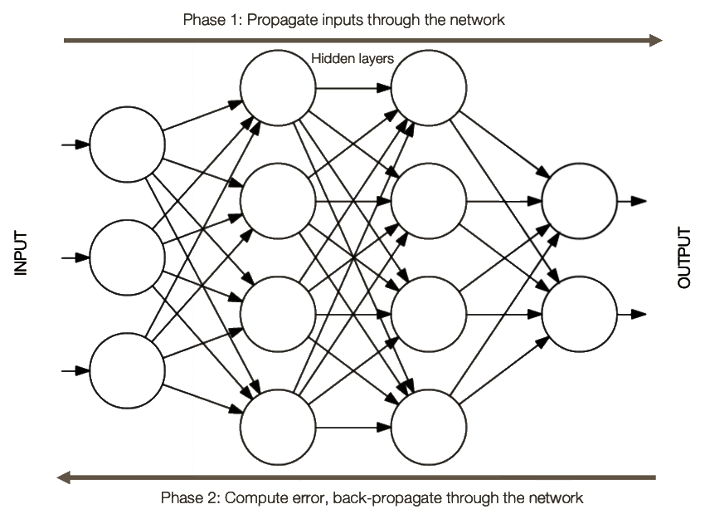

Figure 24.3 - Backpropagation. After a forward pass, computing the predicted out from inputs by propagating the activation through the layers, we can compute the error and loss for a particular input. To update each weight in the network, we have to back-propagate the error from the output nodes to the previous hidden layer, from the hidden layer to the input layer or another hidden layer, all the way back to the first set of linking inputs to the activation of the input layer.

24.4 - Backpropagation in a nutshell
Backpropagation is an algorithm that aims to distribute the (prediction) error seen at the output layer backwards through the network, computing at each step and each layer how much each of the node contributd to that error. In this way, the nodes that contributed more to the error will see larger changes in their weights than nodes that had little to no inlfuence on the error. In order words, it backpropgates the error seen at the output backwards through the network, computing gradients for each node, which are subseequently updated usin gradient descent as optimization algorithm. The actual implementation of backpropogation definitely falls outside of the scope of this course, and even conveying a non-technical inituition beyond what we have already detailed above is a challenge for another day. Safe to say, most of if not all neural netowkr toolboxes have very efficient back propogation algorithms implemented. We felt gradient descent was worth dicussing in great detail in chapter 14, since it is at the heart of not only neural networks but at the heart of so many machine algorithms. It also has a very clear geometric intrepretation that non-technical readers can pick up on, without knowing its exact implementation. We feel that it is not a given that an indepth look at the exact mathetmical proof and implementation of backpropagation will help develop a similar intuition. However, as always, we urge readers to follow the references if they wish to learn more. One more thing about the difference between gradient descent and backpropagation. There appears to be some variation in how different researchers and engineers would describe backpropagation, especially in relation to gradient descent. Some consider backpropagation to have replaced gradient descent, while others see them as complimentary. We feel the latter is a more accurate take. Remember from Chapter 14 that in gradient descent, we need to compute the gradient given the model's output prediction based on its current weights and input, relative to the ground thruth of the actual outcome given the same input- the loss. This gradient tells us how to update the weights of our model. Without being able to 'see' into the distance of a loss landscape, we decide that the best way to reach an optimal valley where the loss is (hopefully) at a minumum, is to step in the direction of the steepest downward gradient. If you have a neural network that only has an input and output layer (like a traditional perceptron), it is very straightforward to compute these gradients. However, this is not the case for neural networks with one or mode hiden layers. The backpropagation algorithm makes it possible to estimate these gradients on all the weights, even those that connect to the hidden layers. The algorithm works backward from the output and computing the contribution of each node in any preceeding layer to the error computed at betweeen predicted and actual outputs. Backpropagation is itself not updating the weights, it merely helps calculate the gradients needed for updating the weights. In tradidtional gradient descent, this additonal step of updating weights is pretty trivial, and perhaps why some see backpropgation as basically doing all the work. However, updating weights doesn't need to depend solely on the gradients. More modern extensions of the fgradient algorithm, such as Adam, are more adaptive and can tweak learning rates and momentum while the algorithm is being trained. To summarize: backpropagation is the algorithm that give you the gradients, gradient descent and extensions of it combine the gradients with other metrics of performance to most optimally update the weights at every iteration and or epoch.

Figure 24.4 - The Scikit learn toolbox for Python is an excellent way to start applying machine learning to your data, including tools to build (relatively simple) multilayer neural networks. For neural networks of considerable size and requiring large amounts of training data, toolboxes that integrate GPU and distributed computing are likely more to train, despite the increased overhead of building models in these toolboxes (e.g. Tensorflow).

24.4 - Scikit-learn
Before committing to Tensorflow as our go-to toolbox to design, implenent and train neural networks, we will use Scikit-Learn, a widely used python machine learning toobox. Scikit-learn has an API that is easier to master, and quicker to develop in, compared to Tensorflow, Keras or PyTorch. It isn't optimized to handle the large amounts of training data modern neural networks use to train, and it provides more cookie-cutter like algorithms. Nevertheless, it is a great starting point to quickly test out some ideas, such as different network architectures, number of hidden layers, activation rules, etc. We therefore use it in this chapter to build a few multi-layer perceptrons, and delay our introduction to Tensorflow for when we dive into the truly deep belief neural networks in the next chapter.

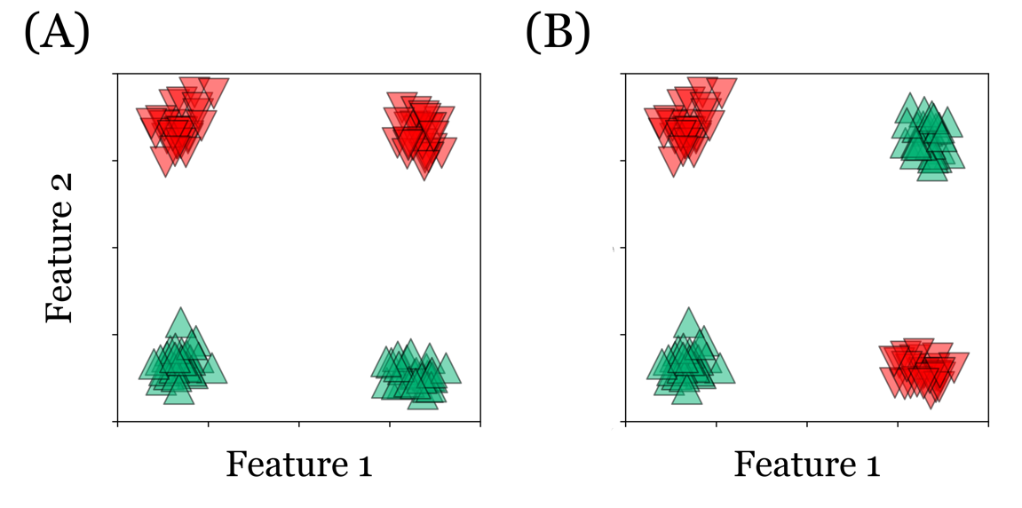
Figure 24.5 - XOR Problem revisited. (A) A linearily seperarble dataset. An infinite number of decision boundaries exist that will perfectly predict the class of each point. (B) A non-seperable dataset. No matter how hard we try, there isn't a single linear decision boundary we can draw in 24.5B.

24.5 - The XOR Problem revisited
Let us briefly revisit why an XOR logic gate can not be modeled by a two layer (input and output) neural network. Instead of the strictly binary logic gate, we can easily create a data set that has the same properties, and therefore the same problem: it is not linearily seperable. Consider Fig. 24.5A and 24.5B. Both show four clusters of data located at each corner. In Fig. 24.5A, the top left and top right cluster are all labeled as 0 while the bottom left and bottom right cluster are labeled 1. In contrast, in Fig 24.5B, the bottom left and top right cluster are labeled 0 and the bottom right and top left are labeled 1. Correctly classifying the data in Fig. 24.5A with a 2 layer neural network is easy, almost trivial - there are an infitie number of functions y = ax + b that we can think of seperate perfectly the two clusters, you can see one of them in Fig. 24.5A, dashed line. Correctly classifying the data in Fig. 24.5B, on the other hand, is impossible. for a 2-layer network Try your hardest, but you won't be able to draw a straight line that has all data points labeled 0 on one side of it, while all data points labeled 1 are on the other side of it. To see why we once more will use geometry to create the necesssary intuition of the XOR problem.

24.6 - 2-layer neural network and linear regression
In Chapters 22 and 23 we discussed, outlined and implemented Rosenblatt's perceptron. Recall that the formally we can express the perceptron as generating output (the prediction) y_{predicted} from inputs X, learned weights W and the perceptron activation function. Specifically: y_{predicted} = f(Xw + b), where Xw is the dot product between the inputs and the weights, b is the bias unit and function f is
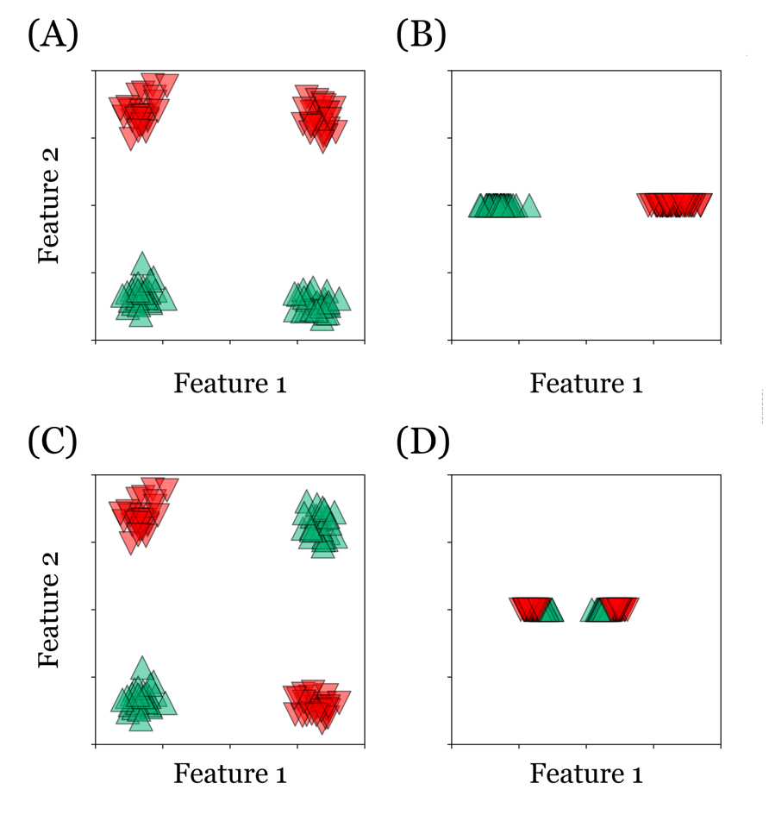
Figure 24.6 - Using OLS, we can estimate the best transformation that collapses the original data in (A) to a single feature (C) which divides the datapoints belonging to each of the two classes perfectly. In contrast, for our data that is not linearly seperable (B), we will find no transformation that cleanly seperates datapoints on the basis of class (C). Additional layers and nonlinearities are needed.
a thresholding function that assigns 1 to any positive output of Xw + b and 0 to to any negative output of Xw + b. If you didn't skip all the chapter up to
the start of our discussion on neural networks, you might see a familar equation in all of this. Indeed, if we ignore the thresholding activation function applied on the output of y_{predicted} = Xw + b (and thus the output in a 2-layer perceptron), the equation is that of linear regression. In linear regression we referred to the columns of X as the different regressors in our data, the rows as the individual
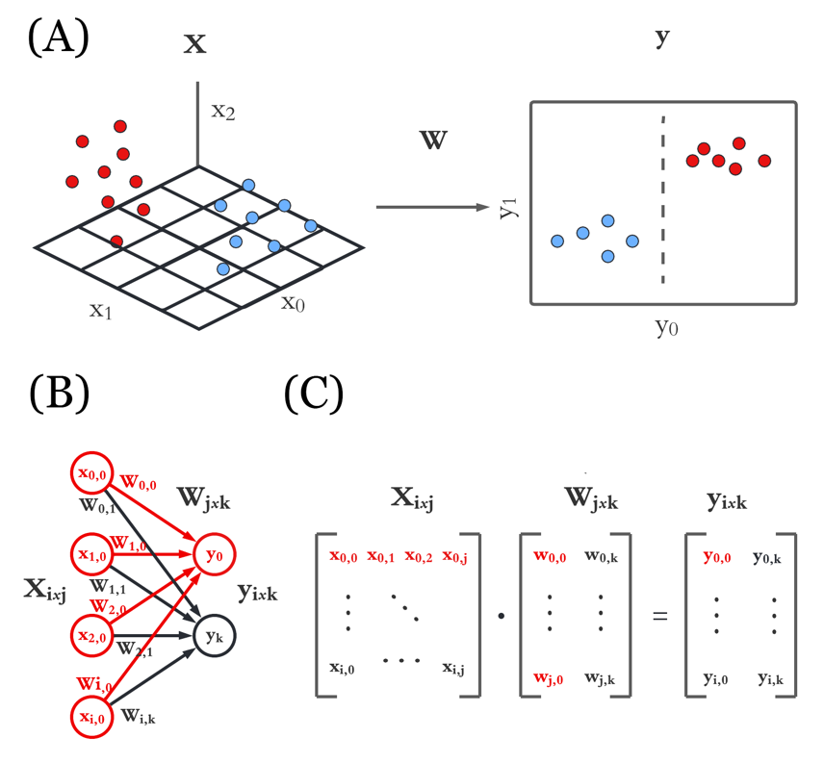
Figure 24.7 - (A) Geometrically, during training we aim to find a transformation oft he inputs X using weight matrix W as to transform all points in X onto a new decision space. In this example, points in 3D are mapped into 2D, where a simple thresholding along the output of even one node y will yield accurate predictions. (B) A neural network layer computing the incoming activity on a particular layer starts with computing the dot product between the vector of inputs X (length 4) and the weights of each node (4 weights per 2 output nodes, plus a bias for each node) to produce response of each node in the receiving layer y. This is mathematically equivalent to applying a linear model in the form y=wX + b seen in (C). If we apply an non-linear activation function to the output of layer 2, the neural network can achieve more complex transformation from layer to layer, allowing it to fit datasets that are not linearily seperable.

data points. In neural networks X represents the input to the network. If we have a dataset X of size n=100 rows by m=4 columns, it means each data point has m=4 dimensions which map onto the 4 inputs nodes of the perceptron. If the output

layer consists of 2 nodes, the weight matrix that links the input and output layers is thus 4x2 elements in size. Each output node j (2 in total) receives activityfrom all 4 input nodes i, where w_{ij} indicates the relative weight of that particular input node i to output node j. We learned previously how to use OLS (ordinary least squares) or gradient descent to estimate the weights W. OLS is a closed form solution, and garantuess the computed weights W are optimal. This doesn't mean it will always give you good models, quite the opposite. If the data we are trying to model using linear regression isn't linear, the weights estimated using OLS are only optimal relative to the assumption the data could have been explained using a linear function.
 | 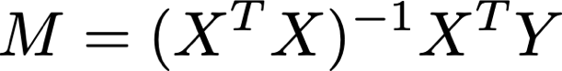 | (24.2)
 | Equation 24.2 - Ordinary Least Squares solution to find the best linear transform M that projects X into Y. If this model, which is completely linear, already does well in transforming the the data points in input X into a space of predicted output, in which points beloning to one class are clear seperated by a linear hyperplane, you have no need for a more complex model. Remember, when you hear hoofs, think horses, not zebras. Or, when you live in Tanzania or Kenya, you probably want to think zebras, not horses. Or consider what is probably the best innovation catchphrase, introduced by the Skunkworks team (responsible for designing many hi-tech planes for the US armed forces, including the U-2, SR-71 Blackbird, F-117 Nighthawk, F-22 raptor and F-35 lighting): 'keep it simple, stupid'.

Again, if we leave out the thresholding, the perceptron model is equivalent to the OLS, although it might not estimate the same optimal weights, as it uses an iterative method, i.e. gradient descent. However, both methods are mathematically equivalent. And since the XOR data isn't linearly sperable, no linear model will perform ever do well on such data. Regardless of whether we frame it is as linear regression or as a neural network model.

24.7 - Testing for linear seperability
How do we know our data isn't linearly seperable? Of course we could spend our days trying drawing hyperplane after hyperplane through our data in hope of finding one that has all inputs of class 1 fall on one side, and all inputs of class 0 fall on the other side of the hyperplane. But this because quite tedious, if not outright impossible for any data set with more than 3 dimensions. Lukcily, we can use linear algebra, specifically OLS itself, to quickly derive an answer to the question of linear seperability. It is based on the following. Imagine you data points of being distrbuted on 1D line, representing the activty of a single output node predicting the one of two. When the class asosciated with the input is 0, the activity of the output node is less than 0, when the class is 1, in output is greater than 0. In this scenario, it is obvious the data is linearly seperable, we only have to test for the sign of the output (which is exactly what the thresholding in the Perceptron model is designed to do). As long as they do not overlap completely, the inputs beloning to each class are always seperable to some degree. And even if the output of each clas overlap partially, there is still an ideal hyperplane that seperates them optimally (at output = 0), even though because of the overlap, 100% prediction accuracy is not obtainable. So how do we relate that observation to the true situation of things in our seperable data set (in Fig. 25.4A) and non-sperable data (Fig. 25.4B)?
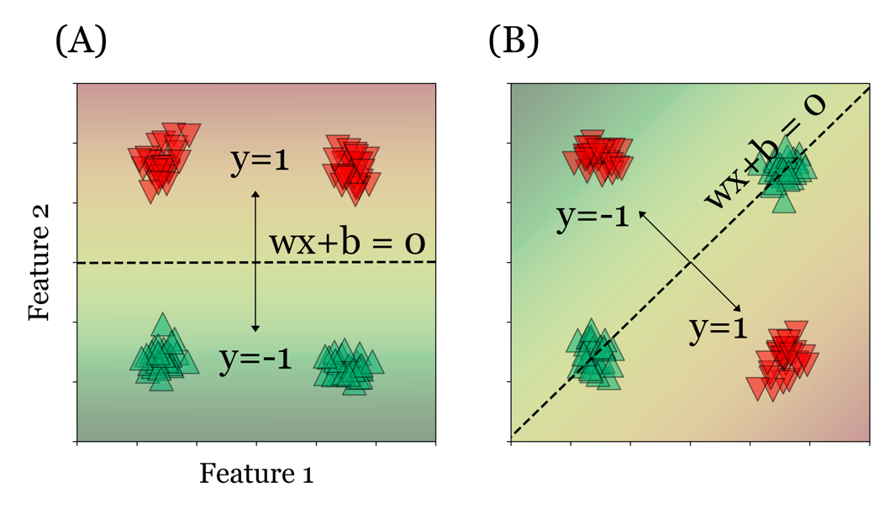
Figure 24.8 - Again, in the case of linearily seperable data (A), it is straightforward to find a decision boundary that perfectly seperates the data points of both classes. In constrast, although we might converge on a set of parameters that specify our decision boundary, in the case of non-seperable data (B) a linear decision boundary cannot not cleanly seperate the datapoints between the two classes.

Enter OLS. Leaving the derivation to textbooks that discuss this topic exclusively and in more depth, we will state the following as fact. If there exists a global transformation (meaning the same transformation is applied to each point) that can geometrically transforams our data into a dataset that is linearly seperatble (like in Fig. 24.5A), that data is linearly seperable itself. This is a great characteristis of linear system. Transform them as often as you want, some properties of the data will not change, like linear seperability, provided the transformatin is a linear one, like the rigid or affine transformation that combine translation, rotation, scaling and shearing we saw in Chapter 12. In practice, you can test for this as follows. Take your original data in n dimensions, X of size (mxn), and associate each data point with one our two outcomes (say -1 for all y = 0 and 1 for all y = 1), yielding a vector Y of mx1. What we aim to find is the best fittin transformation matrix M that mapps our matrix X as close as possible to the vector Y. Since this might require a non-zero translation, we do need to add a column of ones to both X and Y, for reasons we explained in previous chapters. But to recap: the column of ones acts as an intercept or offset, a fixed shift of all data points along each axis independently. In neural networks such an offset is implemented as a bias node, in linear regression a scaler (the b in y = wX + b). The remaining elements of matrix M jointly represent other types of transformations, like rotation, scaling and shearing. We can find the most optimal transformation matrix M onto Y, using OLS, see Eq. 24.1. Subsequently applying this matrix M to X, yields a vector Y_{predicted} that we can plot as points on a single line. If Y_{predicted} shows a clear seperation between points beloning to each class, we can conclude that the original data X itself therefore also is linearly seperable. This is becuse the linear seperability will by retained, no matter what linear transformation we apply. Figure 24.6A and 24.6B represents the data in 24.4A and 24.4C after 1) finding the optimal transformation matrix M between the data X (2-dimensional) and outcome Y (1-dimensional) and 2) applying this matrix to the data X. As you can see in these two figures, the transformation matrix estiamted for Fig. 24A yields a clear speration of the datapoints in Y. In contrast, for the data in Fig. 24B, even the most optimal transformation cannot get all the examples of one class to be to the left of 0 (negative) and the examples of the other class to be all to the right of 0 (positive). You might at this point ask about the thresholding. Can't the thresholding introduce non-linearities that allow for more complex, non-linear models to be captures by 2-layer perceptrons? No, unfortunately not. Not in the case of the 2-layer perceptron.

24.8 - 2-layer Perceptrons with a linear activation function
The thresholding at the output layer does not change the function governing the hyperplane given by the weights. Indeed, when we train a standard input-output layer perceptron model on the same two data sets, the first data set can be used to train a model with 100% accuracy, wheras trainingon the second dataset results a model predicting inputs with an accuracy not statistically higher than chance. This does not change when a non-linear activation function is introduced. You can work through the notebooks to confirm this for yourself, and see Fig. 24.9.
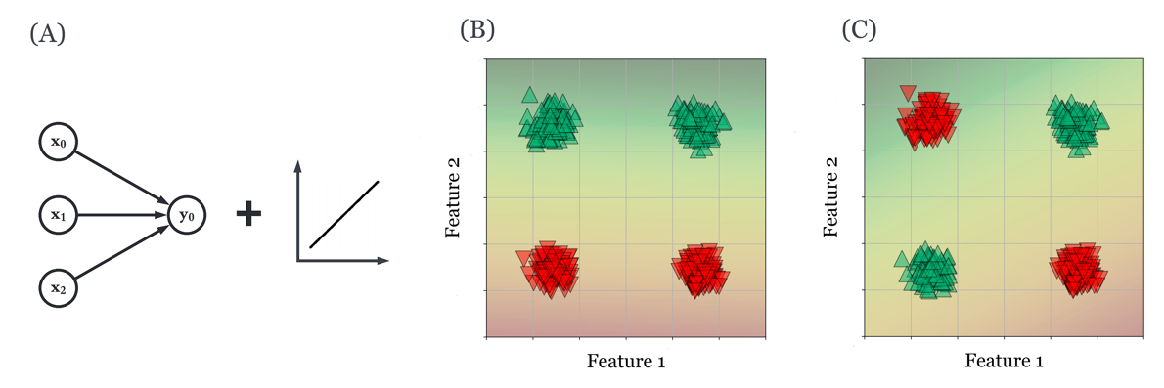
Figure 24.9 - (A) A two-layer Perceptron was trained on the seperable (B) and non-seperable data (C). The gradient significies the probability an new input would be classified as green or red. The seperable data (B) is easily captured by the Perceptron model, and its decision boundary can easily discriminate between the two classes. In contrast, the same two-layer Perception cannot fit a decision boundary that seperates the differetn classes in non-sperable data (C) cleanly and with an accuracy above chance.

24.9 - Non-linear activation functions
In their book on perceptrons, Minsky and Papert rightfully pointed out that indeed 2 layer perceptrons would always fail to solve non-linearly sperably problems. To them, this didn't mean the whole endavor of neural networks had been a waste of
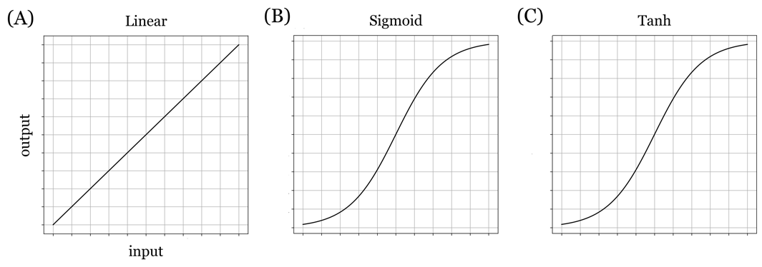

Figure 24.10 - (A) A linear activation function is sometimes also called an identigy activationb function. Mathematically, it is identical to applying no activation function, but instead just propogates the activation computed from the inputs to the layer and the weights on these inputs. (B) The sigmoid function is S shaped so that it assymptotes on both sides of 0. This maps the range of inputs to it to a value between 0 and 1, which is the posterior probability our network assigns to n different outpiut classes. (C) The hyperbolic tangent or tanh function looks very similar to the sigmoid. However, it is bound by -1 and 1, rather than 0 and 1. This means we can't read the output of the tanh activation function as a strictly posterior probability or confidence our networks assigns to our output calsses. However, the tanh function and its derivative have some other mathemtical properties that make them more efficient to train neural networks.

time. On the contrary, they were quick to point out that going beyond two layers, and introducing intermediate or hidden layers, no-leairly sperable problems could be solved. This is true, but it isn't the whole truth. There is another ingredient that our new geenration of multilayer networks needed in addition. And that ingredient: non-linear activation functions implemented through the neural network governing the output of all nodes, not just a thresholding of the final output layer. Simply put: non-linear activation function allow neural networks to learn non-linear relationships. A single hidden layer that implements a non-lineariry is already sufficient to solve the XOR problem, but introducing a single hidden layer without such a non-linearity is not.

24.10 - Linear, Tanh and Sigmoid activation functions
We can introduce non-linearities in our network by taking the strictly linear component of the output (computed from the inputs and weights using linear algebra) and adding a non-linear component to it by applying a non-linear activation function. Starting with our discussion on linear regression in Chapter 14, we have looked at how we could optimally apply a linear transform to our input data as to minize the error between our model's prediction and the ground truth data (Fig. 24.10A). Shortly afterwards, we introduced the sigmoid function (Fig. 24.10B) for a diferent algorithmic objective: classification (e.g. logistic regression), rathet than regression. Here, we add an additional common activation function, the hyperbolic tangent, or tanh for short (Fig. 24.10C). Although both the tanh and sigmoid are very similar in their shapee former has some beneficial prorperties over the sigmoid in terms of its mathematical properties. The only other noteable difference is that eventhough both sigmoid and tanh are S-Shaped curves, the sigmoid lies between 0 and 1. whereas tanh lies between 1 and -1. Although they do introduce the non-linearities we so desperately need to build more complwex and interessting neural networks, neither activation fucntions is without drawbacks. Specifically, as both activation functions asymptote away from 0, we can see a phenomenon occur in which the gradient is very flat away from the origin of the state space (due to the asymptoting of the activation fucnctions themsleves). This is referred to as vanishing gradient problem, and several methods exist to counteract it. The most powerful of these is to introduce yet another non-inear activation functin: the Rectified Linear Unit (ReLU). To us, the introduction of the ReLU function is one of the insights that accelerated mutlilayer neural networks into a new age where they were rebranded as Deep Belief Neural Networks (understandably, because the term deep belief neural net does have an intriguing and high-tech ring to it). Therefore, we hold of on discussing it in greater detail until the next chapter.
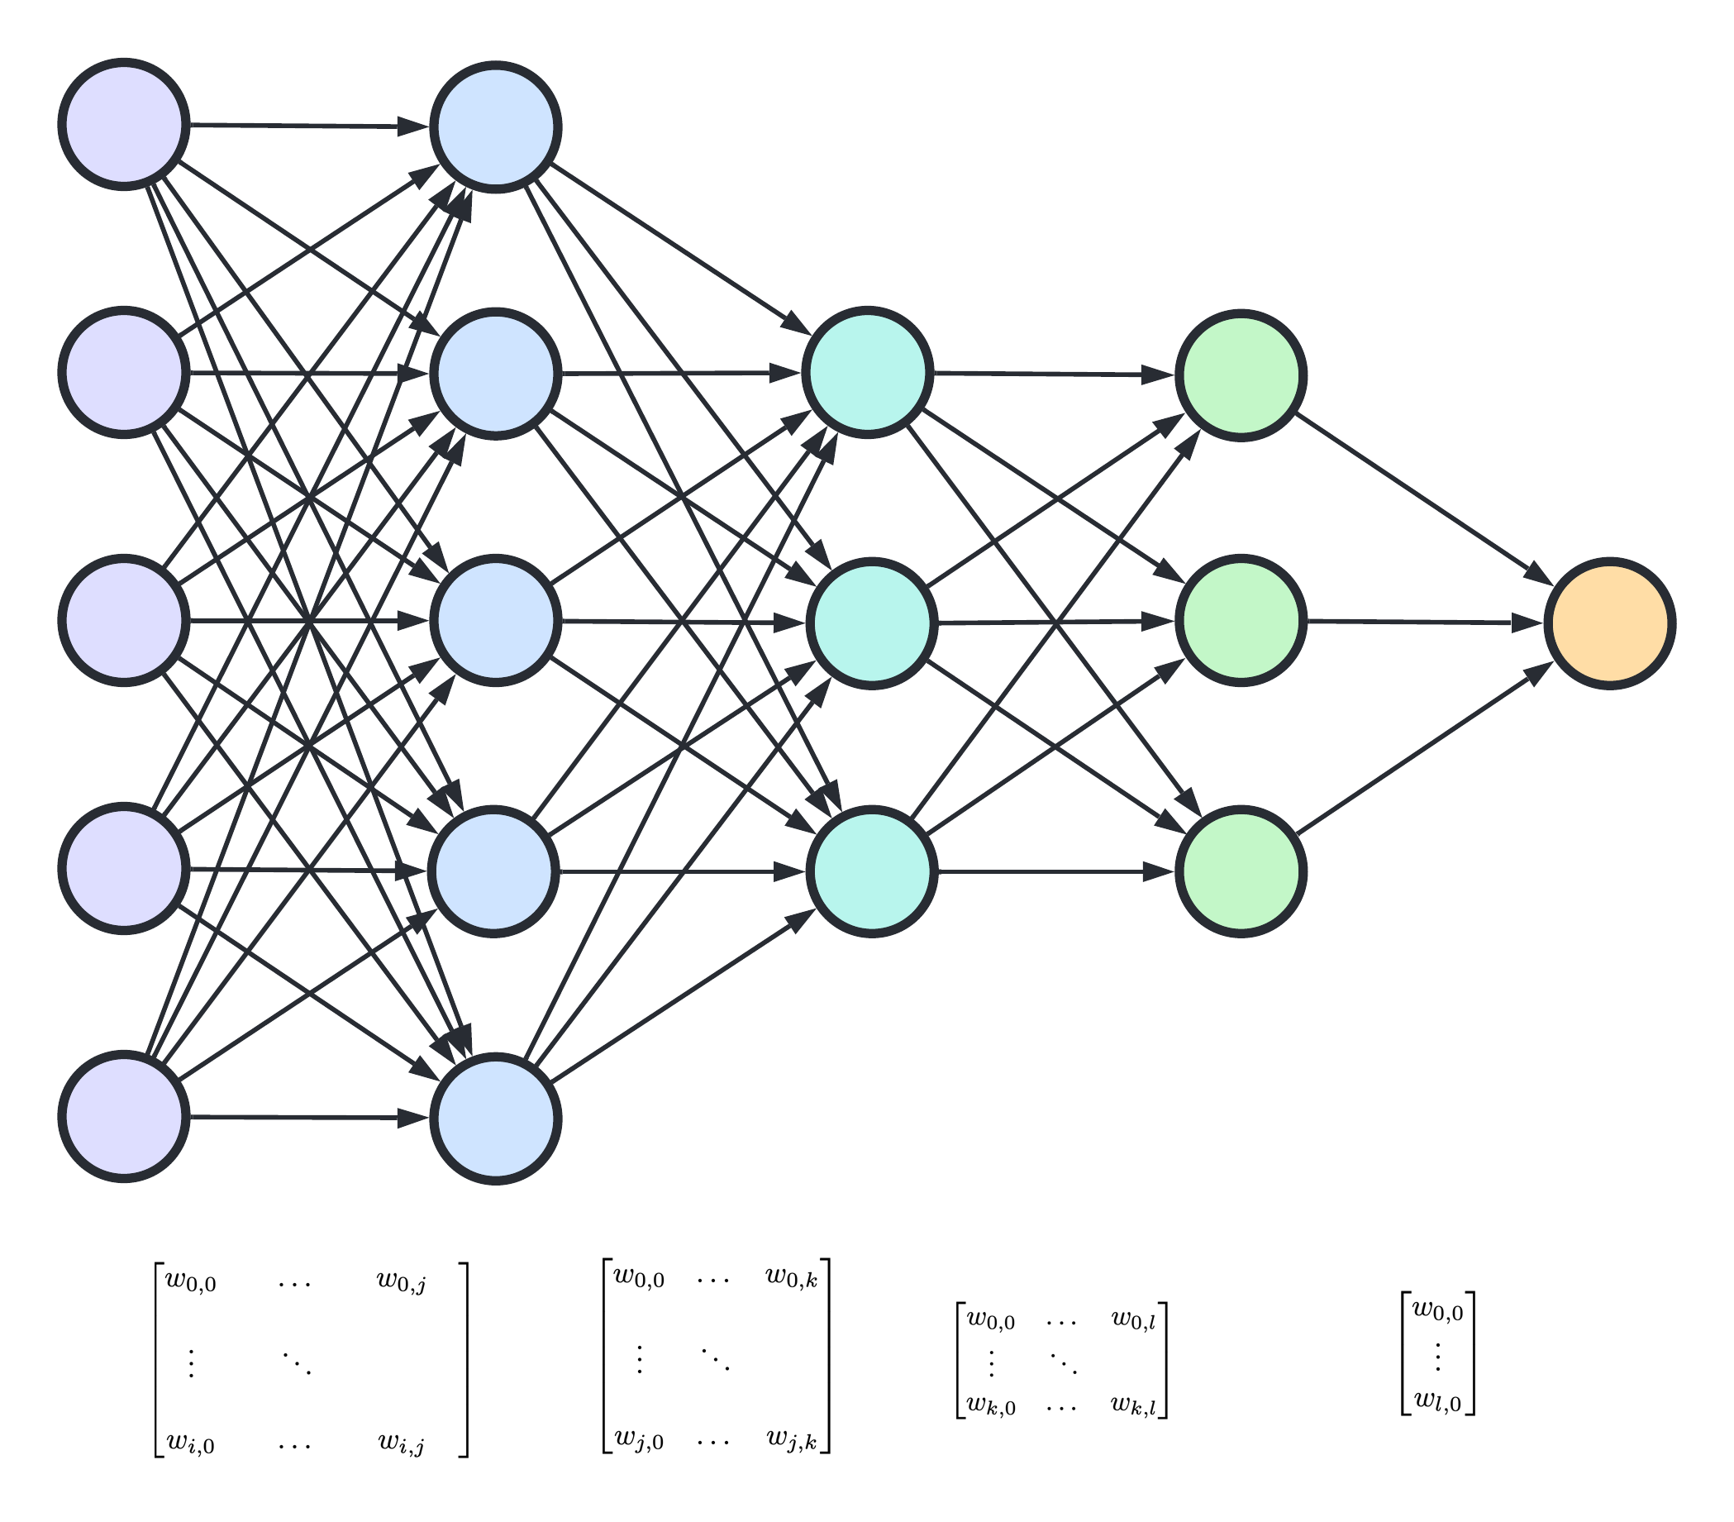
Figure 24.11 - If a series of layers do not introduce any non-linearities, but instead passes along only the computed output y from inputs X, weights W and bias b: y = wX + b, the sequence of transforms can be combined into a single matrix, applied once to the inputs to obtain the networks output. This reduces a neural network of n number of hidden layers back to the original Perceptron model, still unable to be trained on linearily non-seperable input data.

24.11 - Multi-Layer neural networks with linear activation functions
Having hidden layers is not a garantuee that the mapping between linearly non-seperable data can nevertheless be learned by a multi-layer algorit h. As outlined before, a sequence of layers with strictly linear activations is mathematically equivalent to combine all weights matrices into a single one and directly computing the network output from its inputs by a single forward pass using a linear activation function, see Fig. 24.11. Verifying this observation, we trained a 3 layer neural network (3 nodes in the inputs layer, 3 nodes in the hidden layer, and 1 node as the output). Indeed, even with an extra layer, but without any non-linearities introduced by a non-linear activation functions, the multilayer neural network also failts to accuractely predict the non-seperaly data, see Fig. 24.12
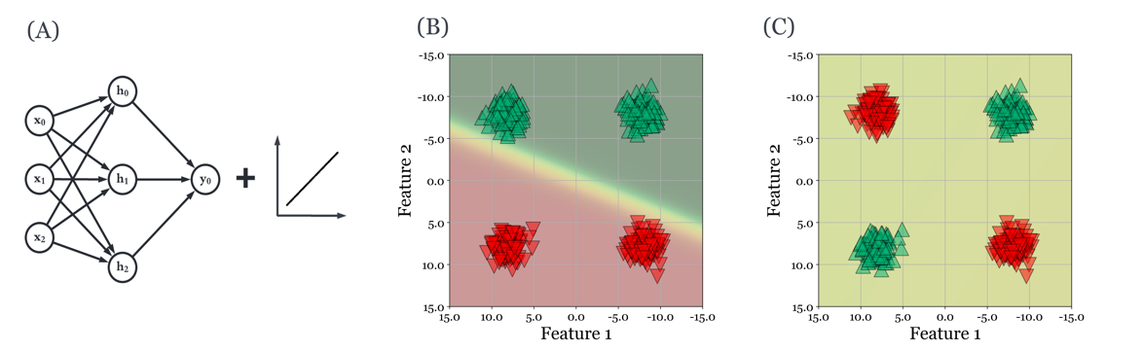
Figure 24.12 - (A) Network architecture with a linear activation function. (B) for linearly seperable data, a linear decision boundary (color gradient) is easily found. (C) Without any non-linearities introduced, however, our multilayer neural network does not allow us to now seperate the data points of each class any better than our 2-layer traditional perceptron.

24.12 - A Multi-layer perceptron with strictly linear acitivation functions.
Without any non-linearilties, a multilayer perceptron computes the activity A of layer n as the dot product of the inputs to this layer (from a previous layer or the actual inputs to the network itself) and the associated weights W of each node of layer n on each of the inputs reaching it . This activity is the output of the nodes in layer n and might serve as the input to a subsequent layer, or represents the final output of the network. If the latter, we can tresshold this activity, giving us a prediction of the outoyt class the input was assocatiated with. However, before that final layer where we might (or might not) threshold the data, or perhaps apply a sigmoid function to it, no matter how many layers we create between inputs and outputs, the computation from layer to layer remain strictly linear. In algebriac terms, we are taking an input X and applying a sequence of transformation matrices M to it, out until the final output. And as we have already seen, these type of transformations are commutative. Commuative means that the order in which we apply these matrices does not change the outcone. From this, it also follows that all the transformations at each layer can actually be combined into a single transformation, by computing the sequence of dot products between each layer's weight (read: transformation) matrix. In otherwords, a strictly linearly multilayer neural network is equivalent to a two-layer network when all the weight matrices to each layter have been combined into a single one. And that means that no matter how many layers we keep adding, it will never do better than a two-layer perceptron.

24.13 - Multlayer neural network with non-linear activiation functions
As mentioned above, we need more than just creating intermedaite layers to solve problem like the XOR logic gate. Specially, we need to introduce non-linearities. Non-linearities allow the neural network to find much more complex, non-smooth, and non-monotic hyperplanes that we need to build a neural network that can
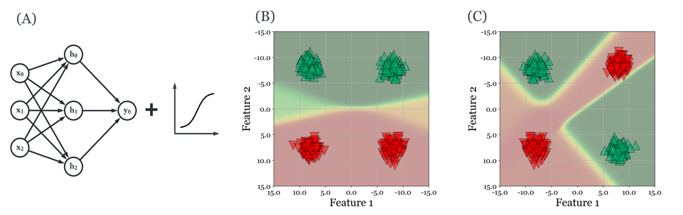
Figure 24.13 - When we introduce a non-linear activation function (tanh in our example), our network is able to learn more complex decision boundaries, making a previously non-seperable problem seperable. The colored gradient background continues to signal the output of the neural network at each combination of feature 1 and feature 2. As you can see, the decision boundary now seems to fold to data belonging to each class is highly complex, but very effective in accurately predicting outputs from inputs.

problems that aren't linearly seprable. And the place to introduce such non-linearities is the activation function of each node, at each layer. So how does a multilayer perceptron, or any type of multilayer neural network, solve the XOR problem (and others) pointed out by Minskey and Papert. Again, geometry allows us to convey this intution without the need for pages of mathematical proof.

24.14 - Predicting Breast Cancer Risk
Moving away from such contrived examples like a XOR logic gate, we will use a real world data set to train a multi-layer neural network. The dataset links several lifestyle choices, bio and demopgraphic data, and environmental factors to a possible positive or negative breast cancer diagnosis. Our task, oviously, is to see what risk factors have the biggest impact, and if two or more risk factors together interact to have a non-linear effect on cancer risk. It is helpful to look beyond mere measures of accuracy ,recall, precision and F1 scores. Instead, here we will focus on not just accuracy, but also to visualize and interpret the model, so as to build further on our intution of what these networks end up learning. We introduce the concept of interpretability here, and will have a closer look at how exactly the weights in our new model capture the relationship between demographics and breat cancer risk.

24.15 - Predicting Genre from Spotify Audio Features
In a second demo notebook, we use data obtain from music streaming service Spotify. Using their API, users can retrieve artist and track information, including any musical genres an artist identifies with, as well as 12 audio features extracted from each track. These audio features were developed in-house at Spotify, and little is known about how they were derived as the features remain proprietary at this point in time. Luckily, the features are somewhat self-descriptive, and all 12 are listed in Table 24.1. The genres used by Spotify are quite detailed and numerous, so we sought to consolidate them into a few top level genres : 'house','rap','pop','rock','metal',' jazz','electronic','latin','k-pop','country', and 'hip hop'.

24.16 - Conclusion
In the chapter we had a closer look at how hidden layers and non-linear activiation functions can be used to fit more complex datasets.

24.17 - References
- Linnainmaa, S (1976). The representation of the cumulative rounding error of an algorithm as a Taylor expansion of the local rounding errors. Master's Thesis (in Finnish), Univ. Helsinki, 1970.
- P. J. Werbos (1982). Applications of advances in nonlinear sensitivity analysis. System Modeling and Optimization. Proc. IFIP, Springer.

